**Impacts of the U.S.-China Trade War on Chinese Dairy-Livestock Belt**

YOUMIN LI

# Abstract

# The trade war began in 2018 when the U.S. imposed tariffs on Chinese goods. In response, China implemented retaliatory tariffs on a wide range of U.S. agricultural products exports, which included major commodities like soybeans, oats, forage and alfalfa. This paper examines the impact of the U.S.-China trade war on dairy production in the Chinese dairy belt, located in Inner Mongolia. Time-series data from the Ministry of Agriculture and Rural Development of China show a significant decline in per capita milk production (P < 0.05). The findings reveal that tariffs on commodities with lower elasticity have outsized economic effects, exacerbating supply chain disruptions. This paper also offers insights into international trade tariffs and policy strategies to mitigate their impact.

# Keywords: Trade policy, Forage, Dairy, Agribusiness, Tariffs

JEL CLASSIFICATION: Q17, Q18

# Introduction

Over the past decade, for widely different reasons, various countries ranging from the U.S. to India and Vietnam have utilized tariffs, export taxes, and other barriers to trade to address domestic political and policy concerns (Smith & Glauber, 2020). An economic conflict between China and the U.S. has been ongoing since January 2018 began setting tariffs and other trade barriers on China (P. Fajgelbaum et al., 2024). Among those countries' trade policy barriers, the U.S.-China trade war has significantly impacted the dairy and livestock industry in China, especially Chinese dairy-livestock belt, which is located in grassland pastoralism at 40°N in Inner Mongolia. Since 2018, China and the U.S. have imposed a number of high-percentage tariffs on dominant products exported to each other in the course of gaming on both sides of the trade policy (P. D. Fajgelbaum & Khandelwal, 2022). Among them, trade in agricultural products is an area of strategic importance. After three rounds of countermeasures, tariffs on more than 90 percent of U.S. agricultural exports to China were raised to 25 percent. This has led to a series of chain effects in the short term on agricultural products that are highly dependent on Chinese exports to the U.S. The effects were particularly significant on soybeans, forage, oats and alfalfa.

Researches on trade policy have important contributions for three reasons. Firstly, conceptually, long-run changes to trade barriers likely affect not only farmers and producers in a region but also with consumption and even food security (Schmitz & Helmberger, 1970). This paper relates to studies that evaluate trade war impacts on dairy production inputs price, productivity, consumption, and welfare changes. This paper also speaks to the literature on the welfare implications of international trade war.

# Literature Review

The cereal import dependency measure estimated by the Food and Agricultural Organization of the United Nations (FAO) is an indicator of the importance of trade in meeting food security needs (Farrokhi & Pellegrina, 2023; Grunert, 2005). In recent years, North America remains a significant exporting region for cereals, soybean and grain, although it is relative importance has declined. The U.S. is one of the largest producers of alfalfa hay, and China is one of its biggest markets. The added tariffs have disrupted this trade flow. While not as large a market as alfalfa, oat hay was also subject to these tariffs, creating challenges for U.S. producers. And alfalfa, oat and soybean are the main ingredient in dairy cow feed.

In developing country's exports for dairy about 6% of total global exports, so most of those countries are dependent on importing dairy products and forage for their livestock (Sijiu Tong, 2024). Import penetration rates for dairy products were lower in 2018 than in 1995, although recently importer have increased for whole milk and skimmed milk powders. The decline is partly a result of the World Trade Organization (WTO) export subsidy disciplines imposed after 1994 on large dairy exporters like the U.S. and the EU, who had previously relied heavily on export subsidies (Smith & Glauber, 2020). China launched a new round of rural revitalization plans and started a dairy revitalization program in the Inner Mongolia region to reduce its dependence on U.S. forage imports in 2020. The program aims to promote the development of the local dairy industry through subsidies to enterprises and farms that grow forage and raise dairy cow (Bu & Liao, 2022; Cheng et al., 2022).

In China, the birth rate of the newborn population has continued to decline in recent years, and the problem of aging has become more serious. The transition from labor-intensive, traditional agricultural modernization to modern, input-intensive technologies in China has long been seen as a crucial component of economic advancement. The role of international trade for such a shift, however, has not yet been explored (Farrokhi & Pellegrina, 2023). In China, on average, two-thirds of every dollar spent on agricultural inputs such as machinery and fertilizers—which are required for the use of modern agricultural technologies—are paid to foreign suppliers (Farrokhi & Pellegrina, 2023). The intensification of the U.S.-China trade war has exacerbated this unbalanced distribution of agricultural production inputs, with, for example, forage and machinery accounting for a large proportion of the production inputs for dairy livestock products, and very low returns to farmers' labor for production.

On December 22, 2023, China's State Council Tariff Commission announced an extension of the Section 301 retaliatory tariff exclusions on 12 agricultural products, including alfalfa hay, through July 31, 2024 (China, 2023). As of now, U.S. alfalfa hay exports to China benefit from these tariff exclusions, effectively reducing the additional import duties that were previously imposed. While specific information on current tariff rates for oat hay is limited, China's 2024 tariff adjustment plan, effective January 1, 2024, includes changes to import and export tariffs on various commodities. The plan aims to implement provisional import tariffs lower than the most-favored-nation rates on certain goods. However, the exact impact on oat hay imports from the U.S. remains unclear (China, 2023).

# Empirical and theoretical framework

The empirical framework for this study is based on the relationship between trade tariffs policy changes, input prices, and their subsequent effect on dairy production in Inner Mongolia. The analysis utilized time-series data from the Chinese Ministry of Agriculture and Rural Development, focusing on variables such as dairy output, forage costs, and government subsidies. A regression model was employed to quantify the impact of the trade war on dairy production, highlighting changes in productivity, input prices, and consumption patterns. The theoretical underpinnings of this study draw on international trade theory, which suggests that higher tariffs and trade barriers typically lead to inefficiencies in resource allocation (Smith & Glauber, 2020). Specifically, tariffs imposed by the U.S. and retaliatory tariffs by China have led to increased prices for critical dairy inputs, such as feed and machinery, thereby affecting productivity. However, the Chinese government's response, which included subsidies for local dairy farmers and investments in modern farming technologies, helped mitigate some of these adverse effects, leading to gains in self-sufficiency and productivity (Farrokhi & Pellegrina, 2023; Smith & Glauber, 2020).

As for market conditions, higher relative prices of a crop encourage the allocation of resources to the production of that crop, and higher wages or lower prices of intermediate inputs incentivize the use of labor-saving, input-intensive technologies (Farrokhi & Pellegrina, 2023). Higher prices for a net exporting country (U.S.) are likely to improve incomes for smallholder and other farm households but increase average prices for urban populations and, perhaps, food insecurity among the urban poor (Farrokhi & Pellegrina, 2023; Smith & Glauber, 2020). Farrokhi & Pellegrina (2023) have well studied that trade in crops (i.e., agricultural outputs) generates efficiency gains by making room for international crop specialization Reductions in trade costs of agricultural inputs widened the productivity gap between low-income and middle-income countries while compressing the gap between middle income and high-income countries. Moreover, the indirect welfare effects of trade—via the transmission of the benefits of growth in the productivity of agricultural inputs across country borders—were remarkably large (Farrokhi & Pellegrina, 2023). Access to a country's (China) domestic agricultural and food markets by exporter (U.S.) from other countries is often restricted by tariffs and nontariff barriers. Lower tariffs benefit domestic consumers through lower prices, but higher tariff can reduce distortions that insulate domestic producers from global market prices (Gaigné & Gouel, 2022; Ji et al., 2024).

Tariffs generally insulate producers from competitors, but their costs to domestic consumers can be an incentive for unilateral liberalization and loss of social welfare (Farrokhi & Pellegrina, 2023). In addition, domestic subsidies for agricultural commodities may have complex implications for food security in developing countries. Developed economies like the U.S. and emerging developing countries like China are likely to subsidize domestic agricultural production and have often done so in ways that expand domestic production and exports while reducing imports (Smith & Glauber, 2020). Indicated as Figure 1. When China imposes tariffs on U.S. forage imports, it causes the supply of forage TS move leftward to S, then, the price rises to P1. The decrease in consumer surplus for forage importers in China is Harberger triangle - abc. The U.S. exporter lost producer surplus - dbc, due to export amount reduced Q*-Q1 (Van Kooten et al., 2022). Because of the rise in tariffs, the price of forage inputs increases and domestic demand is partially reduced accordingly. Domestic forage suppliers are then incentivized by price and policy subsidies to increase domestic supply. Therefore, this is a complex dynamic simulation process. Overall, however, the supply of forage to China's dairy herd decreased and the average cost of dairy production raised.

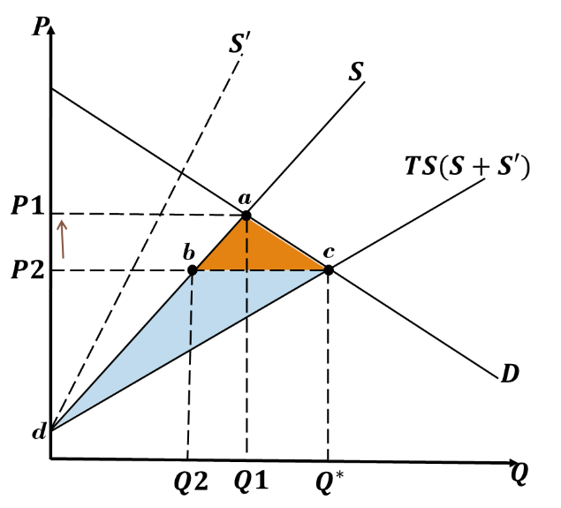

Figure 1: Tariffs on import forage in China

**Trade war impacts**

The trade war have negative impacts on China's capacity for dairy products in the short term. In response to the trump-era trade war, Chines government showed restraint in order to protect exports needed to revive its economy, and trade protectionism is shifting to the long term (Steinberg & Tan, 2024). As a result, this shift in ground opinion is likely to make it harder for China to justify continued trade with the U.S. At the height of the trade war, tariffs on U.S. agricultural products ranged between 10% to 25%, with alfalfa and other hay types falling into this range (*China*, 2020; Rose, 2024). Alfalfa and oat hay are significant U.S. exports, particularly to China, which rely on these products to feed its livestock, especially dairy cows. The heightened tariffs led to increased prices for imported feed, including alfalfa, oats, and hay, which are vital inputs for dairy farming.

Higher tariffs on forage imports increase the average cost of domestic dairy and livestock products in China. In retaliation to the U.S. tariffs, China imposed additional tariffs on these types of hay, making price moved from P2 to P1 for Chinese buyers (as shown in Figure 1). This had a significant impact on price competitiveness, as Chinese buyers turned to alternative suppliers from other countries and reduced their import volumes altogether because of higher price. The increased tariffs on U.S. imports resulted in higher costs for dairy inputs, which led to increases in domestic dairy prices. As shown in Figure 2, which shows a decreasing trend in local production per capita. Consumption, on the other hand, is on an upward trend, and at the national level, the domestic dairy market is under pressure of over demand. So the rise in input costs pushed the Chinese government to adopt a more self-reliant approach, focusing on enhancing domestic production capacity.

Government subsidies and investments in dairy infrastructure helped to offset these cost increases, ensuring that local dairy remained competitive against imported products. These efforts aimed to strengthen the local supply chain and stabilize dairy production despite disruptions in international trade (Sijiu Tong, 2024). However, the results of these efforts are not evident in the short term, with both domestic dairy consumers and producers suffering some degree of loss due to trade war, while forage producers stand to profit. An increase in the cost of domestic dairy and livestock products will lead to a decrease in the market competitiveness of domestic suppliers of dairy and livestock products, as more price-competitive imported dairy and livestock products will enter China. Besides, the trade war between U.S. and China disordered the Chinese domestic supply of grass feeds market in the dairy industry. But higher price of alfalfa, oats and hay simulates the productivity of Chinese domestic farmer. In the previous, export subsidies have long been viewed as particularly trade distorting because of their targeted use for specific commodities in specific markets. But this benefits countries with relatively low national incomes and inadequate food supplies, especially those that depend on imported food (Ji et al., 2024; Smith & Glauber, 2020).

The trade war has increased the gap between supply and demand for dairy and livestock products in China. Tables 1 and 2 show the time-series regressions for the Chinese Dairy Livestock Belt, with a significant downward trend in per capita production over the trade war period (coefficient is 1.14 and P-value < 0.05). While local per capita consumption shows a significant upward trend (coefficient is -0.233 and P-value < 0.05). Although this paper does not collect data on per capita consumption of dairy products nationwide, the trade tensions coincided with the growing demand for dairy in China, driven by consumer preferences for healthier diets (Sijiu Tong, 2024). As a result, there is potential for further expansion of the supply-demand range for dairy products in China, with trade tariff restrictions accelerating this change. In order to reduce the gap in supply and demand for dairy and livestock production in China, South-South trade in agricultural foods has substantially increased (Smith & Glauber, 2020).

Figure 2. Production and consumption of dairy per capita in Chinese dairy belt

Note: 1. PCOr: the observed value of per capita production of dairy products. 2. PCOop: the regressed per capita dairy products. 3. RPCCr: the observed value of per capita consumption of dairy products. 4. RPCCop: the regressed per capita consumption of dairy products.

Table 1. Regression results of trends in per capita and rural consumption of dairy products

|  |  |  |  |  |  |  |
| --- | --- | --- | --- | --- | --- | --- |
|  | Coef. | Std. Err. | t | P > |t| | [95% Conf. Interval] | |
| RPCCop | 1.141776 | 0.1648225 | 6.93 | 0.000 | 0.7689212 | 1.51463 |
| PCOop | -0.2331796 | 0.0500897 | -4.66 | 0.001 | -0.3464902 | -0.1198689 |
| _cons | 2020.523 | 3.897209 | 518.45 | 0.000 | 2011.707 | 2029.34 |

Table 2. Significance test of the regression for trend of per capita dairy production and consumption

|  |  |  |  |  |
| --- | --- | --- | --- | --- |
| Source | SS | DF | MS | Number of obs = 12  F(2,9) = 89.98  Prob > F = 0.000  R-squared)= 0.9524  Adj R-squared = 0.9418  Root MSE = 0.86992 |
| Model | 136.189277 | 2 | 68.0946137 |
| Residual | 6.8107725 | 9 | 0.756752506 |
| Total | 143 | 11 | 13 |

Another stakeholder in this trade war is governments they get revenue from tariffs. The revenue from tariffs on imports come from the exporter. [Importing businesses pay tariffs](https://www.nytimes.com/2018/11/29/us/politics/how-tariffs-work-china.html) and decide whether to pass any portion of the cost on to consumers through higher prices in China (Rose, 2024). The tariffs that China imposed on U.S. exports were calculated to broadly match the value of U.S. tariffs, avoiding a spiral of escalation, but they were economically costly for the U.S. agricultural exports to China suffered, compelling U.S. to channel tens of millions of dollars' worth of subsidies to farmers (Steinberg & Tan, 2024). The record shows, however, that tariffs on imports have not yielded significant tax revenue (Rose, 2024). The revenue generated by tariffs for China during the trade war would have been a temporary boost, but it came at the cost of higher prices for Chinese consumers. By late 2019, the U.S. had imposed tariffs on roughly $350 billion of Chinese imports, and China had retaliated on $100 billion U.S. exports but with expense welfare loss of approximately 0.3% of GDP (P. D. Fajgelbaum & Khandelwal, 2022). As shown in Figure 3, after tariff is applied, the excess demand decreases to $ED_{1}$ and domestic price increases to P1, then the welfare loss is $(bhgf) – (acb+dfe)$ which equal to 0.3% of GDP in China.

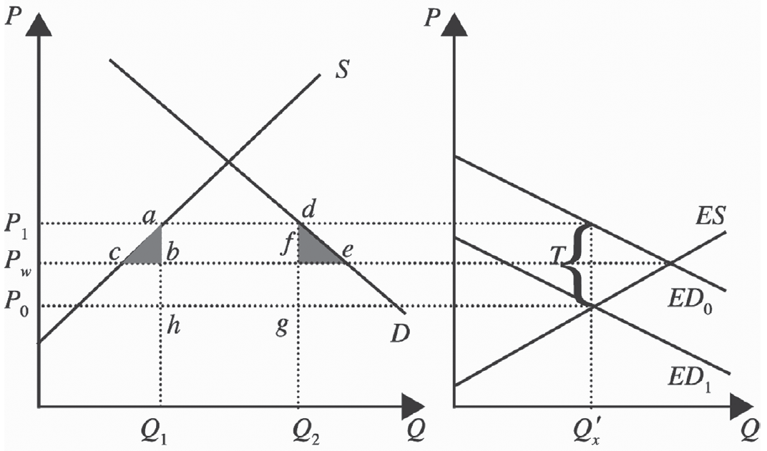

Figure 3. The welfare lose in China due to Tariffs

Richer countries' domestic agricultural subsidy and export restraints programs may have long-term adverse real income and food security impacts in lower income countries (Smith & Glauber, 2020). In the context of agricultural commodities, the U.S. have used some subsidy on agriculture and export restraints and with the primary objective of lower prices for the agricultural food commodity within the country but to reduce the commodity's availability on world markets and raise its price on the international market, and removing government surpluses (Gaigné & Gouel, 2022; Moss et al., 2024). It makes the price of import forage higher but dairy production imports lower than domestic supply market in China. This makes China without production advantages in markets such as dairy products, beef and lamb. Therefore, China need to import them (Gaigné & Gouel, 2022; Smith & Glauber, 2020).

The dairy and livestock production companies in China which benefit from reduced competition but suffered from higher inputs costs. Family farms emerging and get higher price competitiveness. According to the China Food Consumption Report 2022, the number of family farms in China has risen significantly in the post-covid19 era, especially in Inner Mongolia, where income from local dairy farms has become more optimistic. Many residents are shifting their place of dairy consumption to local family farms. This consumption is not usually reflected in macro statistics. So the true per capita consumption growth is likely to be steeper.

China's trade diversification away from the U.S. made up its response to the trade war. PIIE research shows that China has sought out alternative markets for its agriculture imports, even while the U.S. remains reliant on Chinese import demand (Rose, 2024). China has also ratified its participation in the Regional Comprehensive Economic Partnership (RCEP), the world's largest free trade area by market size, and applied to join the Comprehensive and Progressive Trans-Pacific Partnership (CPTPP), neither of which includes the U.S. as a member (Rose, 2024; *China*, 2023). China's diversification into alternative markets also means that future U.S. tariffs will have a smaller bite and weaker leverage.

**Discussion**

Dairy producers and forage exporters should stay informed about policy changes that could affect market access because the agricultural sector remains sensitive to policy shifts. As of 2024, the trade situation between the U.S. and China, particularly concerning agricultural products like alfalfa and oat hay, remains affected by lingering tariffs from the trade war that began in 2018. These tariffs range between 10% and 25%, which has impacted U.S. hay exporters by making their products more expensive for Chinese buyers and reducing competitiveness in the Chinese market (*China Import Export Tariffs in 2024*, 2023; *China*, 2021; *China*, 2020). China's demand for U.S. alfalfa remains strong due to its dairy industry, but ongoing tariffs, non-tariff barriers, and currency fluctuations continue to create headwinds for U.S. exporters.

Additionally, recent reports indicated that China has made some tariff adjustments in 2024, but these largely focus on other commodities and sectors. The tariffs on U.S. agricultural products like alfalfa and oat hay have not seen major reductions as part of these adjustments (75, 2023; China, 2021). After the new election, tariffs may be imposed on 60 percent against Chinese goods, 10 percent against products from the rest of the world. The indiscriminate imposition of tariffs would no longer be confined to a trade war with China, if that is where the U.S. is headed, but a war against trade itself (Wolff, 2024). The new tariffs will be measured affects more than $18 billion in trade coverage, as compared with total U.S. merchandise imports of $3.826 trillion in 2023 (Steinberg & Tan, 2024; Wolff, 2024).

The findings of this study illuminate the multifaceted impacts of the U.S.-China trade war on China's dairy sector. Increased tariffs on alfalfa and oat hay disrupted the input supply chain for dairy farmers. These challenges initially weakened China's dairy production capacity but concurrently spurred policy reforms aimed at enhancing domestic self-sufficiency. Subsidies for local forage production, investments in modern farming technologies, and support for regional dairy bases in Inner Mongolia have collectively improved the sector's resilience​​​. Besides, increased tariffs and rising import costs also led China to ramp up policies supporting local production. These policies provide financial incentives for dairy production, forage production, and improving breeding practices to boost output and quality standards.

This study highlighted the economic costs of protectionism, which are increasing in input prices reduced market competitiveness and limiting access to affordable dairy products for Chinese consumers while increasing financial strain on producers. Regression analysis confirms a statistically significant downward trend in per capita production, highlighting the adverse effects of the trade war on productivity. Increasing demand underscores the importance of aligning production capacities with evolving consumer preferences to stabilize the domestic market. There is a critical need for a balance between short-term protective measures and long-term strategies for sustainable agricultural development.

Domestic agricultural production is expected to be especially vulnerable to the impacts of climate change and environment over the next 30 years (Smith & Glauber, 2020). Future research can integrate these dimensions into economic models to better understand trade policy impacts on agricultural productivity.

**Conclusion**

This paper provides the study of the impacts of trade-war on the rise of dairy and livestock productivity in China. Decoupled trade-war policy has dramatic impacts on the industry. The paper provides insights about the importance of tariff in trade between U.S. and China. The imposition of tariffs led to increased input costs, which initially threatened the stability of dairy and livestock production. However, the Chinese government responded with a series of measures aimed at bolstering domestic production, reducing reliance on imports, and ensuring food security. These measures included subsidies for local forage production, investments in agricultural infrastructure and farming technologies, and the establishment of model dairy farms, all of which contributed to mitigate some of these adverse impacts and improve resilience of the dairy industry (Smith & Glauber, 2020). ​​​

Although tariff revenue from Chinese imports grew following the implementation of higher tariffs, its share of total U.S. tariff revenue declined in recent years as trade shifted to other countries. The average Chinese tariff rate on imports from countries other than the U.S. has fallen from 8.0 percent to 6.5 percent since the trade war in 2018 (Steinberg & Tan, 2024). Consumers and businesses adjusted their purchasing behavior in response to higher tariffs, often substituting taxed goods with alternatives. This behavior reduces the effectiveness of tariffs both as a deterrent to imports and as a significant source of revenue. So tariffs imposed on higher elastic commodity have lower welfare effects on trades. Such as semiconductors, lithium ion batteries, and electric vehicles has lower elastic would have higher impacts on trades and economics. Tariffs on non-ordinary industries which are strategically important beyond their contribution to GDP, and the magnitude of the tariff increases is large (Steinberg & Tan, 2024).

As China continues to diversify its trade partnerships and invest in domestic agriculture, the dairy and livestock sector demonstrates resilience in the face of international trade disruptions (Smith & Glauber, 2020). The experience of Inner Mongolia provides a valuable case study for other regions navigating similar trade challenges. Moving forward, free trade policies and international collaboration will be pivotal in ensuring the long-term sustainability and competitiveness of agriculture​​​.

Free trade policies are widely viewed as contributing to improved food security by enabling countries to exploit their comparative advantages, reducing food insecurity by increasing a country's gross domestic product, per capita incomes, and funding for social safety net programs (Smith & Glauber, 2020). Free trade policies allow countries to exploit their comparative advantages in economic activity (Van Kooten et al., 2022). Policymakers must navigate the trade-offs between protecting domestic industries and fostering an open, liberalized trade environment that enhances global food systems (*China-Mexico Economic Relations*, 2024)​​. And the trade policy changes can have far-reaching effects on agricultural productivity and food security, particularly in countries that are heavily reliant on imports. The experience of Inner Mongolia's dairy industry highlights the importance of government intervention in mitigating the adverse effects of trade disruptions and promoting sustainable agricultural development. The overall agricultural economic benefits of a liberalized trade environment for agricultural commodities are potentially substantial.

**References**

75. (2023, April 7). *China—Import Tariffs*. https://www.trade.gov/country-commercial-guides/china-import-tariffs

Bu, D., & Liao, Y. (2022). Land property rights and rural enterprise growth: Evidence from land titling reform in China. *Journal of Development Economics*, *157*, 102853. https://doi.org/10.1016/j.jdeveco.2022.102853

Cheng, X., Xu, D., Sun, H., Zheng, M., & Li, J. (2022). Rural Spatial Differentiation and Revitalization Approaches in China: A Case Study of Qingdao City. *International Journal of Environmental Research and Public Health*, *19*(24), 16924. https://doi.org/10.3390/ijerph192416924

*China: China Extends Section 301 Tariff Exclusions on 12 Agricultural Products | USDA Foreign Agricultural Service*. (2023, December 29). https://fas.usda.gov/data/china-china-extends-section-301-tariff-exclusions-12-agricultural-products

*China Import Export Tariffs in 2024*. (2023, December 25). China Briefing News. https://www.china-briefing.com/news/china-import-export-tariffs-in-2024/

*China: Market Overview - Alfalfa Hay and Other Forages | USDA Foreign Agricultural Service*. (2021, December 6). https://fas.usda.gov/data/china-market-overview-alfalfa-hay-and-other-forages

*China: Updated Guidance on China's Retaliatory Tariffs and Tariff Exclusions Process for U.S. Products | USDA Foreign Agricultural Service*. (2020, August 7). https://fas.usda.gov/data/china-updated-guidance-chinas-retaliatory-tariffs-and-tariff-exclusions-process-us-products

*China-Mexico Economic Relations: Trade, Investment, and Opportunities*. (2024, November 11). China Briefing News. https://www.china-briefing.com/news/china-mexico-economic-relations-trade-investment-and-opportunities/

Fajgelbaum, P. D., & Khandelwal, A. K. (2022). The Economic Impacts of the U.S.–China Trade War. *Annual Review of Economics*, *14*(1), 205–228. https://doi.org/10.1146/annurev-economics-051420-110410

Fajgelbaum, P., Goldberg, P., Kennedy, P., Khandelwal, A., & Taglioni, D. (2024). The U.S.-China Trade War and Global Reallocations. *American Economic Review: Insights*, *6*(2), 295–312. https://doi.org/10.1257/aeri.20230094

Farrokhi, F., & Pellegrina, H. S. (2023). Trade, Technology, and Agricultural Productivity. *Journal of Political Economy*, *131*(9), 2509–2555. https://doi.org/10.1086/724319

Gaigné, C., & Gouel, C. (2022). Chapter 88—Trade in agricultural and food products. In C. B. Barrett & D. R. Just (Eds.), *Handbook of Agricultural Economics* (Vol. 6, pp. 4845–4931). Elsevier. https://doi.org/10.1016/bs.hesagr.2022.03.004

Grunert, K. G. (2005). Food quality and safety: Consumer perception and demand. *European Review of Agricultural Economics*, *32*(3), 369–391. https://doi.org/10.1093/eurrag/jbi011

Ji, G., Zhong, H., Feukam Nzudie, H. L., Wang, P., & Tian, P. (2024). The structure, dynamics, and vulnerability of the global food trade network. *Journal of Cleaner Production*, *434*, 140439. https://doi.org/10.1016/j.jclepro.2023.140439

Moss, C. B., Chegini, C., & Schmitz, A. (n.d.). Gains to Agricultural Research: What We Know and What We Think We Know. *Agricultural Research*.

Rose, A. (2024, September 11). *Americans have been paying tariffs on imports from China for decades | PIIE*. https://www.piie.com/research/piie-charts/2024/americans-have-been-paying-tariffs-imports-china-decades

Schmitz, A., & Helmberger, P. (1970). Factor Mobility and International Trade: The Case of Complementarity. *The American Economic Review*, *60*(4), 761–767.

Schmitz, A., & Nguyen, L. (2022). Seafood supply and demand disruptions: The Covid-19 pandemic and shrimp. *Aquaculture Economics & Management*, *26*(4), 359–383. https://doi.org/10.1080/13657305.2022.2038719

Schmitz, A., & Seckler, D. (1970). Mechanized Agriculture and Social Welfare: The Case of the Tomato Harvester. *American Journal of Agricultural Economics*, *52*(4), 569–577. https://doi.org/10.2307/1237264

Smith, V. H., & Glauber, J. W. (2020). Trade, policy, and food security. *Agricultural Economics*, *51*(1), 159–171. https://doi.org/10.1111/agec.12547

Steinberg, D., & Tan, Y. (2024, May 30). *How will China respond to Biden's tariffs? Look at Trump's trade war. | PIIE*. https://www.piie.com/blogs/realtime-economics/2024/how-will-china-respond-bidens-tariffs-look-trumps-trade-war

Van Kooten, G. C., Schmitz, H. C., Schmitz, A., Moss, C., & Schmitz, T. G. (2022). *Agricultural Policy, Agribusiness, and Rent-Seeking Behaviour, Third Edition*. University of Toronto Press. https://doi.org/10.3138/9781487518400

Sijiu Tong. (2024). *Inner Mongolia on path to dairy industry revitalization*. Retrieved November 11, 2024, from https://govt.chinadaily.com.cn/s/202109/18/WS6145aa80498e6a12c1205e14/inner-mongolia-on-path-to-dairy-industry-revitalization.html